News Release

2018 Chapel Hill/Carrboro Peacemaking Scholarships Awarded

Chapel Hill/Carrboro Peacemaking Scholarships in the amount of $1,000 each have been awarded to Niya Fearrington and Bhairavy Puviindren. Over the past ten years, 22 Peacemaking Scholarships have been awarded to graduating seniors who live or go to school in Chapel Hill or Carrboro, who are intending to pursue a college education, and who meet certain criteria. The criteria include activism, academic study, and career goals that relate to non-violent conflict resolution, global community, social justice, ecology, and/or population. Niya and Bhairavy received peacemaking scholarships because of their excellent qualifications, record of study and achievement, strong letters of recommendation, and their desire to pursue careers as peacemakers.

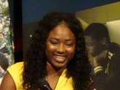
While a student at Carrboro High School, Niya Fearrington was Student Body President, a member of the Minority Student Achievement Network, a NAACP Youth Council Leader, co-founder of Black Girls for Black Girls Club, Varsity Cheerleader Team Captain, and received the William and Mary Leadership Award. This fall Niya plans to attend Howard University, majoring in Healthcare Policy and Administration. She aspires to serve as a nurse, then do health policy work, in order to ensure the best health care for all, while being a mentor for young girls like herself.

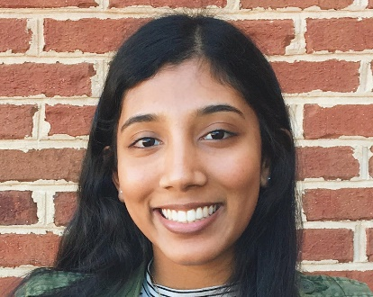
While a student at Carrboro High School, Bhairavy Puviindren was active in the NC for Peace Foundation, co-president of NC Youth for Peace and Red Cross Club, on the steering committee of the Global Health Club, and volunteered at UNC and Duke Hospitals. Bhairavy aspires to a career striving for solutions that help people through medical aid, research and global health, providing effective health care to people who are neglected or ignored, and advocating for equality.

Individuals and organizations who wish to support future peacemaking scholarships can make a financial contribution. Please make a check payable to Peacemaking Scholarship Fund and send it to United Church of Chapel Hill, 1321 Martin Luther King, Jr. Blvd., Chapel Hill, NC 27514. The scholarship application form and bios of previous scholarship recipients are available at http://unitedchurch.org/peacemaking.

Contact:
Jack Denniston
406 Colony Woods Drive
Chapel Hill, NC 27517
919-968-0784
jldenniston3@gmail.com

